|  |
| --- |
|  |
| INB280 - Playtesting and Prototyping Report |
| The Orb |
|  |
| **Muhammed Dogan - n9107665**  **Danyon Fitzsimon - n8854734**  **Peter Tran - n9166203**  **Due: Friday, October 31st 2014** |
|  |

**Tutor: Alex Baldwin  
Workshop Time: Tuesday 3pm – 5pm**

|  |
| --- |
| Version Number 3.1 |

# Summary

## Game Vision

The Orb is a third person stealth action/adventure game for the PC via Steam, PlayStation Network and Xbox Live Arcade. The player plays as Theorb or otherwise known as Theo. He is mysterious Hydrogen based energy form that has arrived on Earth searching for answers about his consciousness and after some time, concludes that his consciousness must be that of a human. The player will step into the shoes of Theo just before he meets Terrence Griffin. Terrence befriends Theo and assists him on his quest for answers by helping him find renowned academic Dr Christopher Key. On his quest, Theo will meet a potential romantic interest and be tracked and attacked by government agents. His most powerful ability for navigating the brutal world will be his ability to Shapeshift into any object or person that he desires and this gives him his best chance of succeeding on his quest.

In addition to Theo’s main Shapeshifting ability, which forms the fundamental basis of the gameplay, the player will have the ability to unlock and upgrade energy based attacks and defensive abilities to be used if and when engaging with enemies in the game.

In each level, the player must reach a series of checkpoints that will progress the level and overall narrative using either just the Shapeshifting ability or energy combat attacks or a combination of both. In addition to this, the player must be aware of their Energy Level at all times as their health and cost to use and certain additional attack and abilities are all combined in one. Failure to do so may result in Theo destabilising (the player’s death). The player will be able to earn Energy points to increase Theo’s strength throughout the levels through a variety of means which include finding books and hidden notes.

The Orb will feature primarily a single player campaign as well as Local and Online Co-op. The single player campaign will focus on Theo’s journey quest to find Dr Key and the answers he holds. While Co-op will put a spin on the campaign by allowing a second player to join the first in playing. This will provide a team-based aspect to the game, as both players will need to work together because they will be linked. This mode will entice and appeal to players who enjoyed Portal 2’s co-operative multiplayer.

The Orb aims to provide the player with a unique mixing of experiences. Its levels will contain exploration, rationalizing and problem solving as players find ways to progress to each of the level’s various checkpoints. There will be moments of intense suspense and anguish as players attempt to stealth their way unseen through the levels and or fight off enemies with attacks that are linked to their health. They will also experience simple and effortless play resulting from a control scheme that draws from some of the best games. The look, feel and style of The Orb will be very dark and gritty, fantasy and sci-fi based due to the nature of Theo and his abilities. All the levels will be based in an urban city scape, set in the modern day. The game world’s look and feel will be very real and life-like, which will be juxtaposed against the player’s character that is far from real in a sense.

The Orb will appeal to adult and mature players who enjoy stealth games such Dishonoured and the rich narrative side of action role-playing games such as Deus Ex: Human Revolution. The game will also appeal to gamers who enjoyed the Matrix films as story elements of The Orb are inspired from The Matrix philosophical look at humanity.

## Prototype Summary

Using Kodu, we created a prototype level for The Orb that focussed on one portion of the game’s mechanics. This was done to demonstrate the basic movements, stealth and combat, as well as to determine if the ability of shape shifting is a fun and practical element. This plan will work best due to KODU’s ability to handle third person, single avatars and projectile-like powers well. As Kodu is a simple game environment tool, it is more effective to keep the mechanics simple. That is why the prototype will only feature extremely stripped down elements.

Using Kodu, we prototyped a demonstration level which displayed the main mechanics of the game as described in the vision. The basic stealth mechanics in the prototype are represented by the abilities of shape shifting and invisibility. The two defensive abilities are decoy and shield. The offensive ability is shooting energy balls.

|  |  |  |
| --- | --- | --- |
| **Ability** | **Button** | **Description** |
| **Stealth Abilities** | | |
| Invisibility | Left Trigger | Allows the player to become invisible to the enemies. The enemies will not be able to target the player if they are invisible. Player takes a small amount of damage every two seconds. |
| Shapeshift | B to morph A to cancel | Allows the player to shapeshift into and a certain object. While shapshifted enemies will not attack the player and the player cannot attack. |
| **Defensive Abilities** | | |
| Shield | X | Protects the player from incoming attacks. Using the shield for too long will inflict damage to the player. |
| Decoy | Y | Launches a decoy in the direction of the player. Enemies will focus their aim on the decoy rather than the player until the decoy is destroyed. The decoy also self-destructs after 20 seconds. |
| **Offensive Abilities** | | |
| Energy Ball | Right Trigger | Deals damage to enemies. A small amount of damage is inflicted to the player with every energy ball shot. |

There are many enemies in the level. The player is able to destroy them using offensive abilities or avoid them using stealth abilities. Enemies that wander in the level will have pre-planned paths, while others will stay put waiting to see the player. At the end of the level, the player will be able to engage in a battle with a boss character.

To unlock the boss fight the player must collect the three keys (represented by coins) to remove the factory which blocks the entrance to the boss area. Once in the boss area the first thing the player must do is position themselves behind the towers that give the boss invincibility. The boss will then shoot its rockets at the towers and destroy them within a few hits. This must be repeated until all of the towers are destroyed. When the towers are destroyed, the boss will no longer be invincible and will enter an enraged phase. During this phase the boss will have more attacks and become more dangerous.

|  |  |  |
| --- | --- | --- |
| **Type** | **Name** | **Description** |
| Bike | Agent | Follows a path and shoots energy balls when it sees the player. |
| Cannon | Blockade | Fires rockets at the player. |
| Turret | Police | Shoots burst of dark energy balls when the player is near. |
| Turtle | Heavy Agent | Roams around and fires homing rockets when it sees the player. |
| Rover | Search Light | Fires homing missiles if the player enters the search light. |
| Blimp | Helicopter | Rapid fires energy balls as it flies over the player. |
| Octopus | Octoputin | Shoots rockets at the player. When the towers are destroyed he becomes enraged and starts shooting energy balls as well. |
| Tower | Tower | Makes Octoputin invincible. |

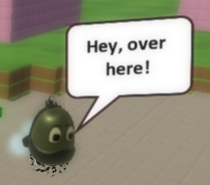There is also a friendly NPC named Terrence. To interact with Terrence players have to bump into him to get his dialogue. Terrence tells the player to collect three coins to unlock the boss fight.

Terrence prompting the player

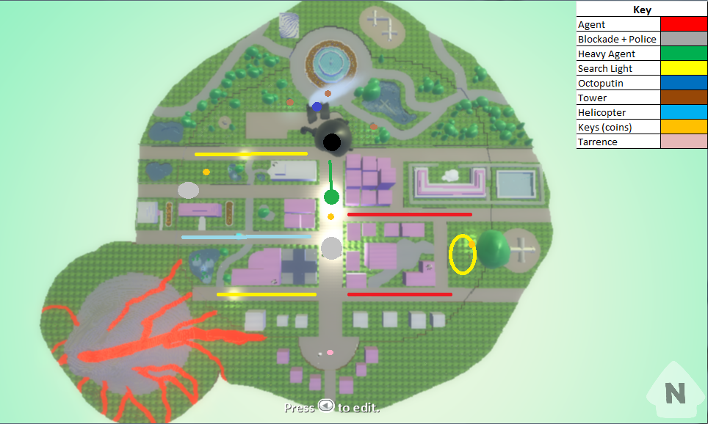In addition, the prototype will feature the unique health system that will force a player to play more stealthily. In order for the player to launch a combat attack, they will have to give up a small percentage of their health. The design document for The Orb details this as the player’s Energy Level. It will act as both the player’s health and ability to make decisions when to attack. The player’s Energy Level over time though will replenish itself.

Prototype Map

Table of Contents

Summary 1

Game Vision 1

Prototype Summary 2

1.0 Playtesting Report 5

1.1 Participants Demographics 5

1.2 Discussion of Findings 7

1.2.1 Survey Analysis 7

1.2.2 Patterns Between Player Demographics 9

1.2.3 Findings and Changes 9

1.3 Detailed Findings 12

General 12

Bugs 15

Appendices 16

Appendix 1 – Playtesting Materials and Notes 16

Script 16

Tester 1 19

Tester 2 27

Tester 3 38

Tester 4 46

Tester 5 56

Test Observer Checklist Tally 66

Additional Playtesting Comments and Notes 67

Appendix 2 – Team member Contributions 68

# Playtesting Report

## Participants Demographics

**Table 1: Player Questionnaire Responses Summary (Below)**

Range: 5 = Strongly Agree and 1 = Strongly Disagree

|  |  |  |  |  |  |
| --- | --- | --- | --- | --- | --- |
| **Player Questionnaire Responses** | | | | | |
| **Question/Statements** | **Player Response** | | | | |
| **01** | **02** | **03** | **04** | **05** |
| Have you seen or heard anything about the game we are testing,  called “The Orb”? | No | No | No | No | No |
| I am an experienced video game player. | 5 | 5 | 3 | 1 | 3 |
| In a normal week, roughly how many hours do you spend playing videogames? | 124 | 5 | 12 | 0 | 6 |
| Please tick the box next to the platforms on which you regularly play games. | Consoles, Computer, Handhelds | Consoles, Computer, Touchscreen Phones | Computer, Touchscreen Phones, Handhelds | Consoles, Touchscreen Phones, Other Platforms | Consoles |
| I enjoy Stealth Action/Ddventure games. | 4 | 4 | 3 | 1 | 3 |
| I enjoy Third Person Shooters games. | 4 | 4 | 1 | 1 | 3 |
| I enjoy Action Roleplaying games. | 5 | 5 | 5 | 1 | 3 |
| Currently, what would you say are your three favourite game genres? | JRPG, RTS, MOBA | FPS, Adventure RPG, MOBA | RPG, Puzzle-Platform, Action | Racing, Sports | RPG, Shooter, Racing |
| What would you say is your least favourite game genre? | Puzzle | Dance | Shooter | Dance | Dance |

As part of the Playtesting process and due to time constraints, we selected and ascertained results from five different individuals with varying degrees of experience with videogames. The Orb is aimed primarily at intermediate and experienced players. Many, if not all of the problems present in The Orb were brought up by all players, which meant experience had nothing to do with them.

All 5 players that were tested were naïve as they answered “no” on the first question of the player questionnaire. The player questionnaire helped the group to determine the breakdown of the facts of the sample size that was tested. All the testers varied in skill level with 2 being experienced, 2 possessing intermediate skill levels while 1 identified as not that experienced. All testers identified as to playing on consoles and 4 out the 5 players listed other platform such as computers and touchscreens. Most importantly, the questionnaire helped determine the demographic categories that the play testers fell into. Out of the 5 players, 2 players (01 and 02) would be part of the core demographic and 2 out of the 5 players would be part of the fringe demographic between core and wide. This is due to their responses to the exact and ‘close cousins’ genres given and what they wrote down for their three favourite genres, while 1 out of 5 players would not be part of the wide demographic. However people can change over time and if improvements are made, maybe the player may eventually become part of the wide demographic. While tester 4 was not part of the target audience of the game, they still encountered problems experienced with the other users and the feedback given and ascertained from them is useful for one day converting the player to the target audience. Additionally, only 1 out of the 5 players was female and all 5 continued to do a deep playtest.

While all information gathered from the 5 players is extremely useful in refining the tested prototype, there are certain limitations with collecting data from such a small sample size. Due to such a small testing sample, the conclusions and solutions drawn from the playtest may not satisfy every player in the core demographic as some issues could be overlook and some patterns maybe missed. So while the sample size observed is diverse, a larger size would be continually more beneficial.

## Discussion of Findings

### Survey Analysis

**Table 2: Player Survey Responses Summary (Below)**Range: 5 = Strongly Agree and 1 = Strongly Disagree  
Aspects Average Ranking: 1-2 = Minor, 2 – 4 = Moderate, 4 – 6 = Major, 6 – 8 = Severe

|  |  |  |  |  |  |  |  |
| --- | --- | --- | --- | --- | --- | --- | --- |
| **Question** | **Player Response** | | | | |  | **Intensity of Issue** |
| **01** | **02** | **03** | **04** | **05** |  |
| The game was easy to learn how to play. | 2 | 2 | 3 | 2 | 4 |  | Moderate to Major |
| The game was fun to play. | 3 | 4 | 3 | 3 | 4 |  | Moderate |
| The game was frustratingly difficult. | 2 | 4 | 3 | 4 | 2 |  | Moderate |
| The game was boringly easy. | 3 | 2 | 2 | 1 | 2 |  | Minor |
| The game’s controls made it easy to do what I wanted. | 2 | 3 | 2 | 2 | 2 |  | Major |
| The stealth mechanics were enjoyable to use. | 3 | 4 | 2 | 3 | 5 |  | Moderate |
| The transformation mechanic was easy to use. | 4 | 4 | 2 | 3 | 3 |  | Moderate |
| The transformation mechanic was enjoyable to use. | 5 | 4 | 3 | 3 | 3 |  | Moderate |
| The game’s background and world was enjoyable to look at. | 3 | 3 | 3 | 3 | 3 |  | Minor |
| The game challenges were appropriate for my skill level. | 5 | 3 | 4 | 1 | 4 |  | Moderate |
| The challenges in the game had enough variety. | 5 | 2 | 3 | 3 | 4 |  | Moderate |
| The game’s story was enjoyable. | 2 | 3 | 2 | 3 | 4 |  | Major |
| The game’s dialogue was enjoyable. | 2 | 2 | 2 | 3 | 3 |  | Major |
| I always understood what I should do next to achieve my goal. | 1 | 3 | 2 | 1 | 3 |  | Major |
| I always understood how to advance my character. | 3 | 2 | 2 | 1 | 3 |  | Major |
| I want to find out what happens next if I were to continue playing. | 4 | 4 | 3 | 2 | 4 |  | Minor |
| I would be interested in playing this game again. | 3 | 4 | 3 | 2 | 4 |  | Minor |
| **Aspects** |  |  |  |  |  | **Average** |  |
| Audio | 7 | 7 | 8 | 8 | 7 | 7.4 | Severe |
| Controls | 3 | 8 | 7 | 1 | 8 | 5.4 | Major |
| Enemies | 4 | 5 | 4 | 2 | 2 | 3.4 | Moderate |
| Gameplay | 1 | 3 | 6 | 6 | 1 | 3.4 | Moderate |
| Game World | 5 | 2 | 2 | 5 | 3 | 3.4 | Moderate |
| Visuals | 2 | 6 | 3 | 7 | 5 | 4.6 | Major |
| My Character | 6 | 1 | 1 | 4 | 4 | 3.2 | Moderate |
| Story | 8 | 4 | 5 | 3 | 6 | 5.2 | Major |

The survey helps provide additional information that is secondary to what was observed and can help backup any assumptions made about the game being tested and what needs to be improved upon for future versions. While audio and visuals are included in the aspects section, they can be disregarded to a degree due to their lesser importance to the playtest and goal of our testing. Kodu is limited in what it can provide in those areas (Audio and Visuals), which the team has already flagged for improvement. The survey results show a lot of aspects that need work to fix.

The first major problem highlighted by the survey is the controls were challenging and confusing to learn, resulting in a steep learning curve (according to 4 out of the 5 participants). This impacts the accessibility and appeal of the game to many if not all gamers (regardless of experience). The problem was mainly caused by inefficient and inadequate communication of information in the game to the player. This is apparent in the fact that there were low scores across all 5 participants for the statements regarding understanding what should be done next to achieve their goal and advancing. This helps to shine another light on why so many participants struggled to pick the prototype up, let alone beat the boss and complete the level.

Although the prototype mainly focused on fundamental gameplay, the game is meant to be a stealth action/adventure game with a focus on narrative experience. While Kodu does not allow for it, the fact that a majority of the testers thought the story and dialogue were not that enjoyable means that this needs to be improved.

In addition to some of these major issues identified by the survey and backed up by observations, there are a host of other issues identified by the play testers in the survey as being moderate. These relate to the difficulty, challenges, stealth mechanics, enemies, the player’s character and the game world.

### Patterns Between Player Demographics

During the Playtesting, the group observed a few different play styles and strategies when the testers first played the prototype with no prior instructions. The players that identified themselves as experienced players (of which there were two) played more aggressively overall, as they thought that their experience with stealth action/adventure games would be enough to succeed in the game. However, due to the slightly unconventional nature of the controls and gameplay, this resulted in more deaths and more frustration from these players. This was mainly again attributed to lack of communication of information which included controls and objectives. The other three players that identified themselves as intermediate or less experience players played more conservatively and died less, as they were willing to take longer time to read the descriptions given and learn the controls. Although they took a more flexible approach, like their experienced counter parts, they still had trouble figuring out where to go and what to do to an extent.

Again this comes down to the lack of communication of information in the prototype. The solutions for both these groups revolve around providing greater and more effective communication of information as detailed in Main Findings and Changes and Detailed Findings.

### Findings and Changes

The main and critical findings from Playtesting, also backed up by the survey, found two main areas that immediate attention. These are communication and camera control.

Firstly, communication was a huge problem that we found plagued our prototype. All testers had difficulty understanding what they needed to do and how they were supposed to do it. This involved understanding the controls, the goals and the enemies. The result of this was that the players found the game hard to learn and play, impacting negatively on their perceptions on the game. To rectify this problem would require multiple solutions to various elements of the game in order to promote a better experience for all players.

Changes and solutions that need to be implemented include:

* Message alerts that would let critical messages show up on the UI and give hints and tips on what to do and current objectives
* Improve Terrence’s delivery of dialogue and information that would allow the player to absorb information in manageable chunks
* Include cut scenes to further enhance visual deliverance of story and background information
* Implement a pause menu that will allow the player to access objectives, view the city map, change control layouts and track scoring and other features
* Create a visual interface for the controls for the player to see
* Create a UI that shows the player’s health, transformation time remaining, score, assigned abilities, and mini-map. The mini-map will display the player and enemies’ locations, the layout of the level and the locations of the objectives through an objective indicator This will show the player where they need to go to, in order to progress
* Create a comprehensive tutorial video and level to allow the player to learn the controls of the game and acclimatise to the controls, game world, enemies and challenges that the player will face

The second critical finding that was identified was that all players noted camera control and view as being extremely annoying, difficult and troublesome for navigating the game world. This also negatively impacted on their experiences of the game. While we were quite limited in what we could do with a third person camera in Kodu, moving forward with the project will require a great camera set up. Due to the game being a stealth action/adventure game, having a great camera is imperative to future success and positive playability when navigating a tight world such as in the prototype.

Changes and solutions that need to be implemented include:

* Separate the camera from the player’s movement. This will allow the player to look all around Theo without the camera snapping back and forth as the camera should be able to pivot freely.
* When the camera moves, the player’s character should turn as well in the same direction
* Make sure the camera doesn’t jump around objects when the player is obscured by one. The camera should always follow Theo and move closer to it if another object is in the way.
* Include inverted and standard camera controls as an option.
* Allow the player to strafe instead of turn

These are only two of the most critical problems that need to be addressed for the future success of the game. However, many of the other issues and problems that the game experienced in Playtesting can be found in the next section titled “Detailed Findings”.

## Detailed Findings

### General

|  |  |  |  |  |  |
| --- | --- | --- | --- | --- | --- |
| **ID** | **Severity** | **Incidents** | **Tags** | **Descriptions** | **Recommendations** |
| 1 | High | 1, 2, 4 | Usability, UI,  Information,  Story/Dialogue | Players were overwhelmed by the text that showed up at the beginning.  A player remarked that the font was hard to read over the background.  The information at the beginning was also all they had.  If they didn’t absorb it there, then they didn’t know how to play. | Create a pause menu that will allow the player to access objectives, view the city map, change control layouts, and track scoring and other features. |
| 2 | Medium | 1, 2, | Communication,  Transformation/Morphing,  Visuals,  Theo | Players were unaware which objects/enemies could be transformed into.  This lead to them trying, failing, and then ultimately giving up after the first few tries. | Colour transformable enemies/objects in order to let the player know they can be transformed into. It will also save them the frustration of trial and error. |
| 3 | Medium | 1, 2, 4, 5 | Playability,  Goals/Objects,  Keys/Coins,  Visuals | Players were unable to recognise the keys and proceeded past them. | Give the keys a glow or something and mark them on the mini-map. This will make them more noticeable to players. |
| 4 | Medium | 1, 2, 5 | Playability,  Searchlights,  Visuals | Players were confused by searchlights during the day time.  The edge of the searchlight was hard to see.  A player said that one of the searchlight’s patterns was weird. | Either change the city to night time, or outline the searchlights with a bold colour. This will make it less difficult to see the searchlight’s range.  Also come up with more realistic searching patterns. |
| 5 | High | 2, 3, 4 | Communication,  Objectives,  UI,  Audio | Players do not know where they are, where to go, or even where the objectives are.  Players are also having a hard time keeping track of enemies.  Players don’t know how the long the transformation stays on for. | Create a UI that shows the player’s health, transformation time remaining, score, assigned abilities, and mini-map. The mini-map should display the player and enemies’ locations, the layout of the level, and the locations of the objectives. This will show the player where they need to go to in order to progress.  Changes in audio and music to depict changes in gameplay and indicate goals and challenges. |
| 6 | High | ALL | Usability,  Controls,  Camera | The camera snaps back to behind Theo whenever the R Stick is let go.  The camera is also quite jumpy, especially around buildings.  Players have also enquired as to inverted camera controls. | Separate the camera from the player’s movement. This will allow the player to look all around Theo without the camera snapping back and forth.  Make sure the camera doesn’t jump on top of buildings when the player is obscured by one.  Maybe also include inverted camera controls as an option. |
| 7 | Medium | 1, 5 | Playability,  Rewards | Currently, rewards don’t have a use, and only serve to confuse players. | Include a reward system by letting the bonuses heal Theo, increasing his maximum health. Also include a surprise for when Theo collects all of the bonuses. |
| 8 | Low | 5 | Playability,  Transformation/Morphing,  Theo | A player finished the level without transforming. | Provide each transformation with a unique (but possibly novelty, or useful in a non-combative way) ability. This will encourage players to experiment with the transformation feature. Even better, hide the bonuses such that some of them can only be obtained in different forms. |
| 9 | Low | 2, 4 | Playability,  Controls, | Players are limited to walking and cannot explore some places (such as the fountain). | Give Theo the ability to jump.  Maybe auto, like in Final Fantasy XIII? |
| 10 | High | 1, 5 | Communication,  Dialogue/Story | Terrence only tells players the mission information once.  Terrence only says that. | Improve Terrence’s dialogue with a simple tree of events. This also allows the player to absorb information in manageable chunks.  By giving Terrence most of the level information, players will be able to absorb all the text in smaller chunks. |
| 11 | Medium | 2, 4 | Usability,  Controls,  Theo | Players wanted to strafe instead of slowly turn, because they kept losing their aim.  Also, dodging becomes difficult. | Allow the player to strafe instead of turn (which can be done with the camera controls anyway).  Also allow players to lock-on to an enemy, which won’t be simply broken by turning. |
| 12 | Medium | 2, 4 | Controls,  Communication,  Visuals | Controls were hard to use, and information on the layout was hard to read.  The result was mixing up controls and/or forgetting them. | Represent controls with images instead of text.  Change the control layout to one that feels more natural. |
| 13 | Medium | 4 | Communication,  Visuals,  Theo,  Health | Players are unaware that Theo’s abilities are fuelled by his health, which represents his stability. | Give Theo a more noticeable destabilization effect as he loses health. E.g. an electrical effect that grows more intense.  Make the player lose less health (but) more often. |
| 14 | High | 2, 3, 4 | Communication,  Usability,  Dialogue/Story,  Audio,  Visuals | Players are unable to read the boss’ dialogue, and thus miss out on the hints that lead them to destroy the towers first.  They are also unaware that the towers are invincible as well, and can only be destroyed by the boss’ own missiles. | Give the boss’ dialogue an audible form, so that the player can hear the boss speak instead of trying to read it while fighting.  Make the representation of the relationship between the towers and the boss’ immunity even more obvious. |
| 15 | Medium | 2, 5 | Playability,  Environment | A player tried to go through the gaps between the buildings.  A player was stuck in front of two buildings and was killed by an enemy patrol. | Make the gaps between buildings larger so that Theo can fit through them and use them as cover and/or alternative routes.  Messages alerts that would let critical messages show up on the UI and give hints and tips on what to do and current objectives. |
| 16 | Medium | 5 | Communication,  UI,  Objectives | A player was unaware that the gate leading to the boss had been unlocked as a part of their actions. | Alerts can pop-up on the GUI, with Terrence doing a voice-over. |
| 17 | Low | 4 | Theo,  Controls | A player commented that being able to sprint would help in tight situations. | Add the ability to sprint when the left thumbstick is pushed down. |
| 18 | High | 1, 2, 3, 4, 5 | Communication,  Enemies,  Visuals | Players often could not tell if certain objects or characters were enemies or not. | Implement bettering lighting and colour aura/highlights to differentiate enemies from other objects and characters. |
| 19 | Medium | 1, 2, 3, 4, 5 | Controls,  Abilities | Players commented on lack of explanation of abilities and didn’t fully understand them. | Create a comprehensive tutorial video and level to allow the player to learn the controls of the game and acclimatise to the controls, game world, enemies and challenges that the player will face. |
| 20 | Low | 1, 2, 3, 4, 5 | Story/Dialogue,  Visuals | Players felt that the wall of text was too much and didn’t feel that there was much story in the prototype | Include cut scenes to further enhance visual deliverance of story and background information. |

### Bugs

|  |  |  |  |  |  |
| --- | --- | --- | --- | --- | --- |
| **ID** | **Severity** | **Incidents** | **Tags** | **Descriptions** | **Recommendations** |
| 21 | High | 1, 2, 4 | Bug,  Theo,  Respawning | Player was killed in morphing mode.  Player did not respawn. | Make sure the player respawns when killed, regardless of mode. |
| 22 | High | 1 | Bug,  Transformation/Morphing,  Theo, | When player ran out of transformation time, they were stuck on the other side of a boundary.  This is because they were right next to it when they morphed back. | Make the boundary thicker.  Mark the boundary so that Theo respawns when he’s over it. |
| 23 | Medium | 2 | Bug,  Enemies | A bug exists where cycles will pick up specific (but undetermined) bots upon contact. This includes the various forms that the player can transform into. | Make sure the enemies can identify the player (even while transformed) as something that cannot be picked up. |
| 24 | High | 1, 3, 4, 5 | Bug,  Camera | Camera obscured by buildings (terrain), to the point where it randomly jumps to on top of buildings. | The camera should be able to pivot freely, regardless of movement.  It should always follow Theo, and move closer if a building is in the way. |
| 25 | Medium | 1, 2, 3, 4, 5 | Bug,  Defensive Shield | The Defensive shield ability takes improper health damage when being used. If X button is tapped multiple times then then player takes unnecessary damage. | Fix defensive shield so that when tapping the X button multiple time will not result in random health loss. |

# Appendices

## Appendix 1 – Playtesting Materials and Notes

### Script

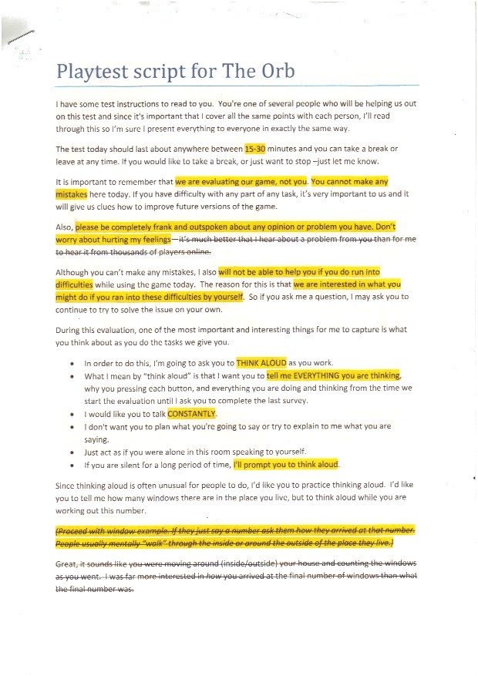

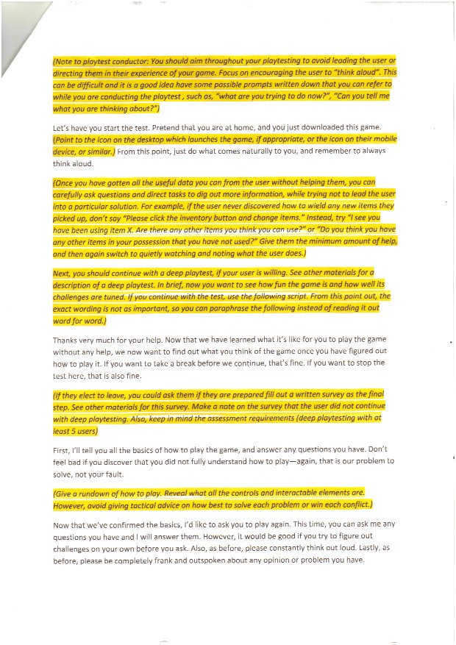



### Tester 1

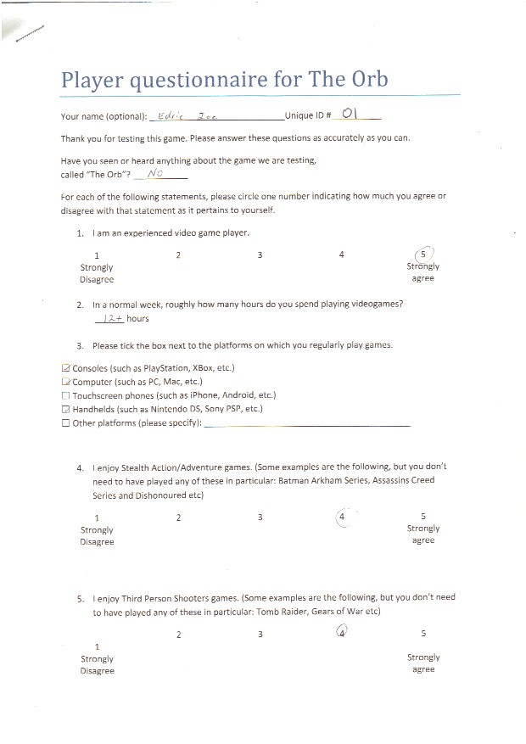

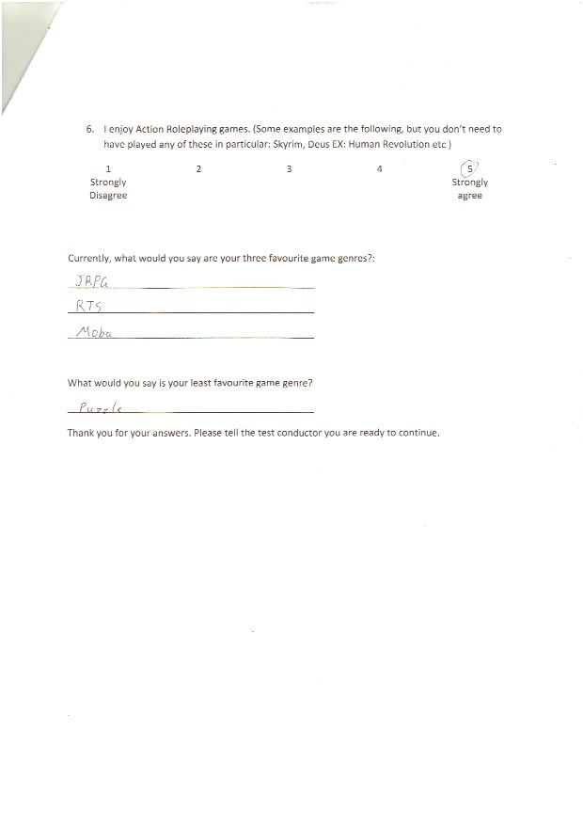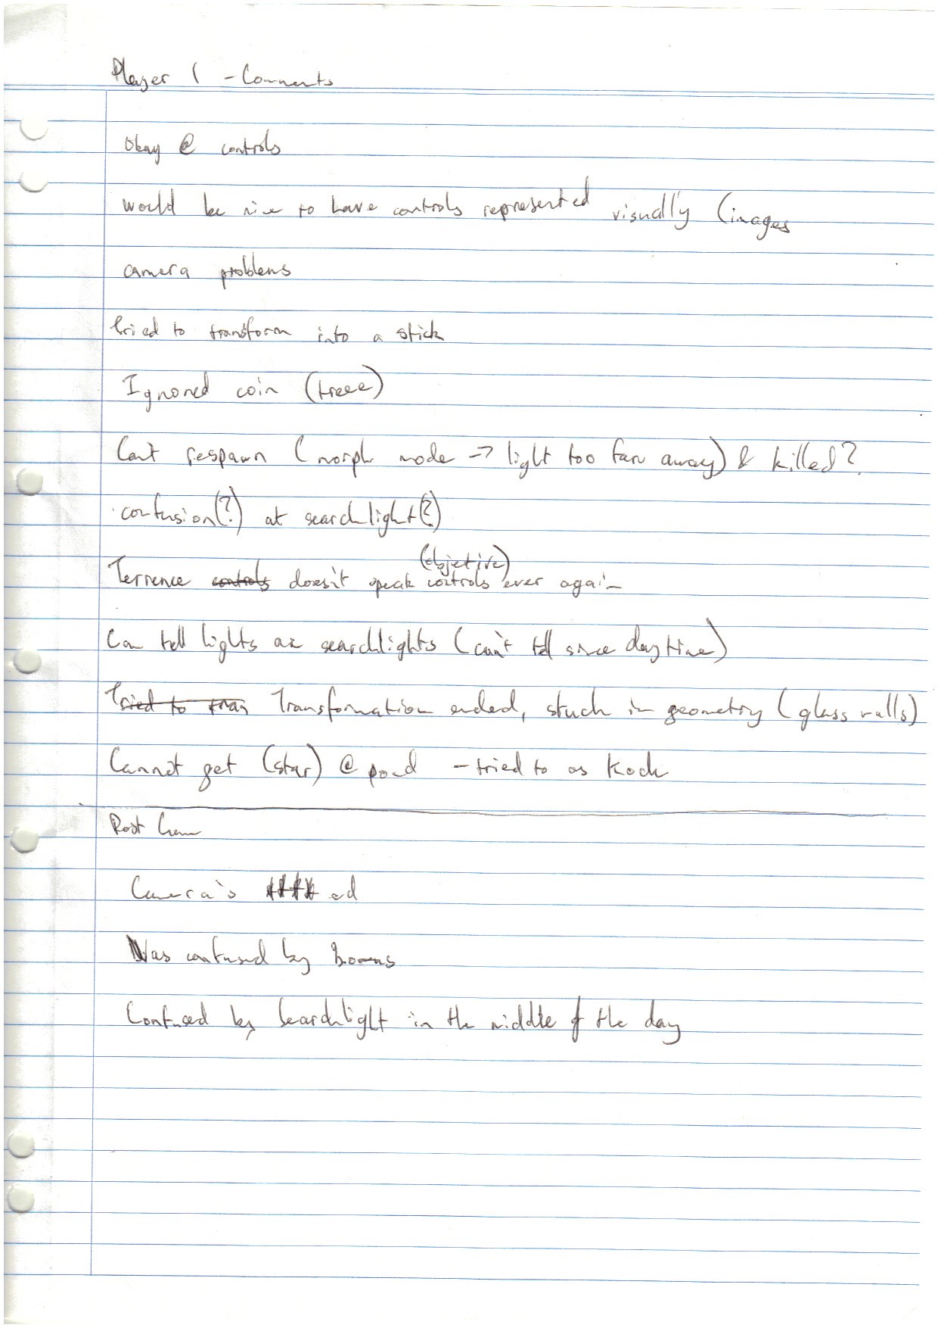

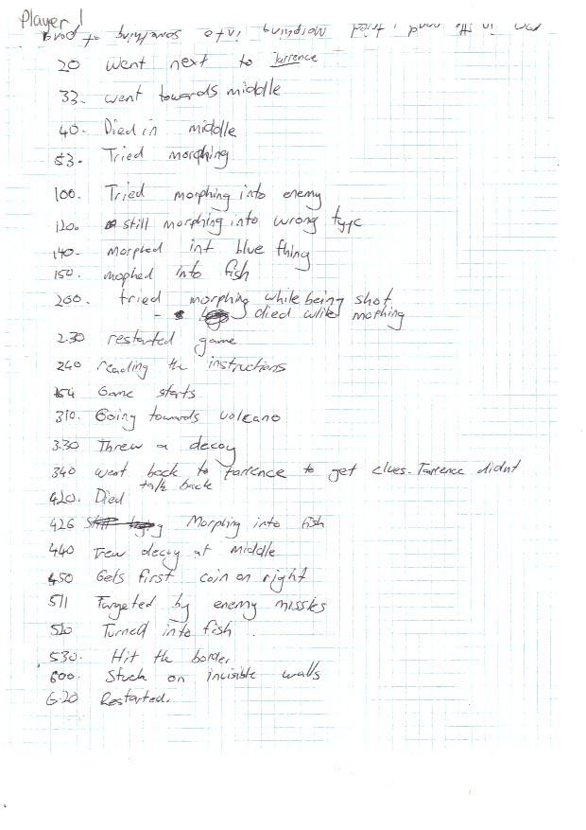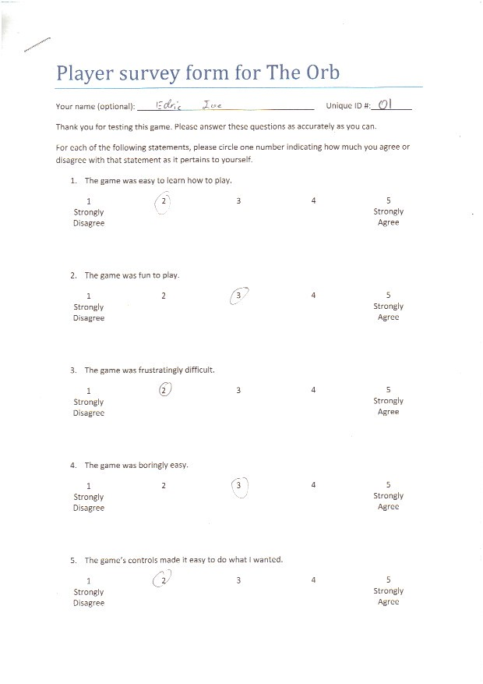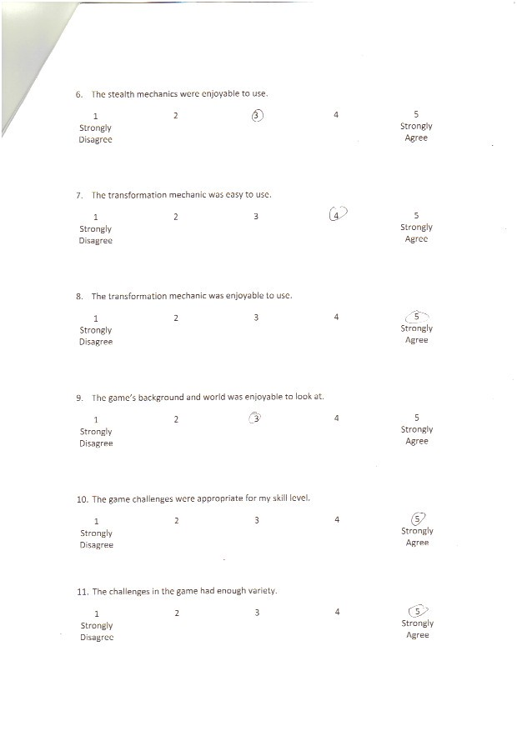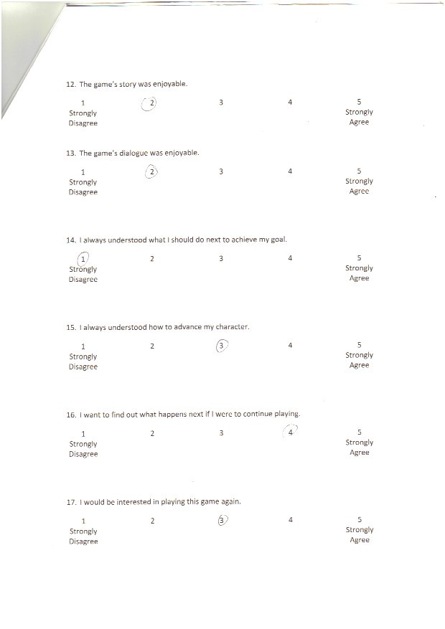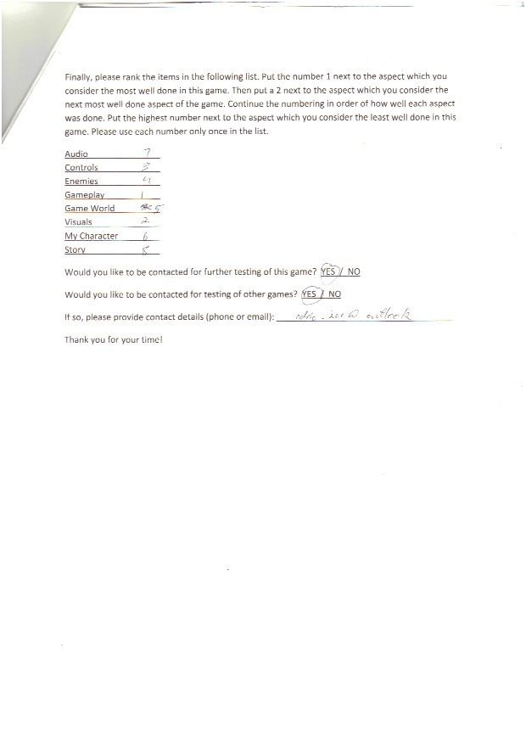

### Tester 2

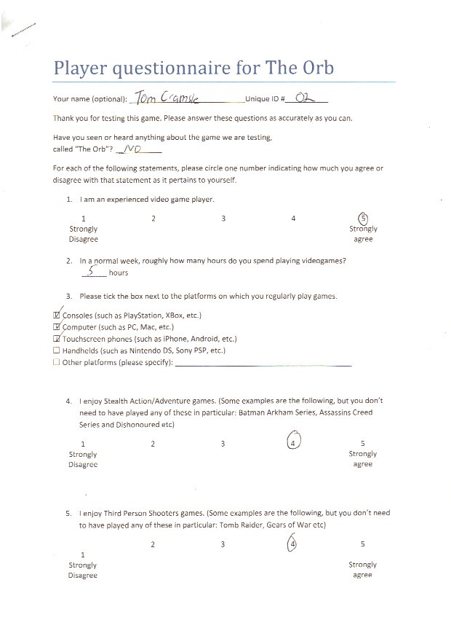

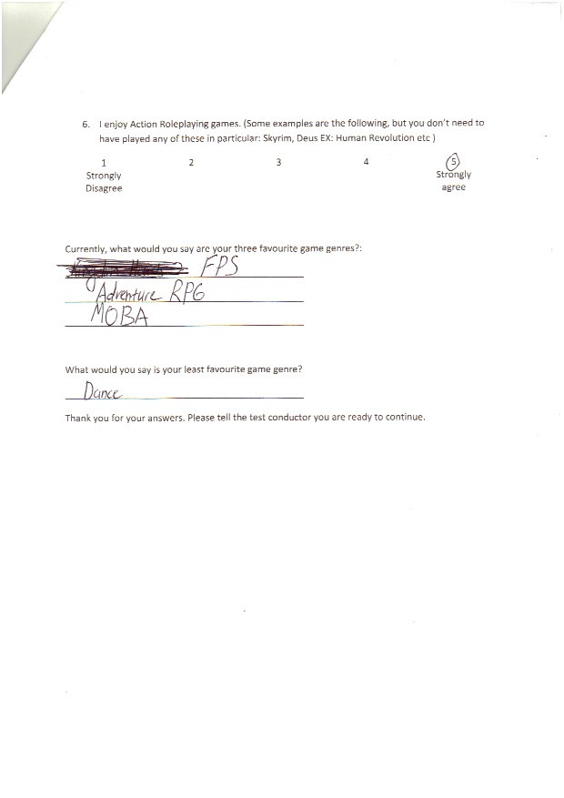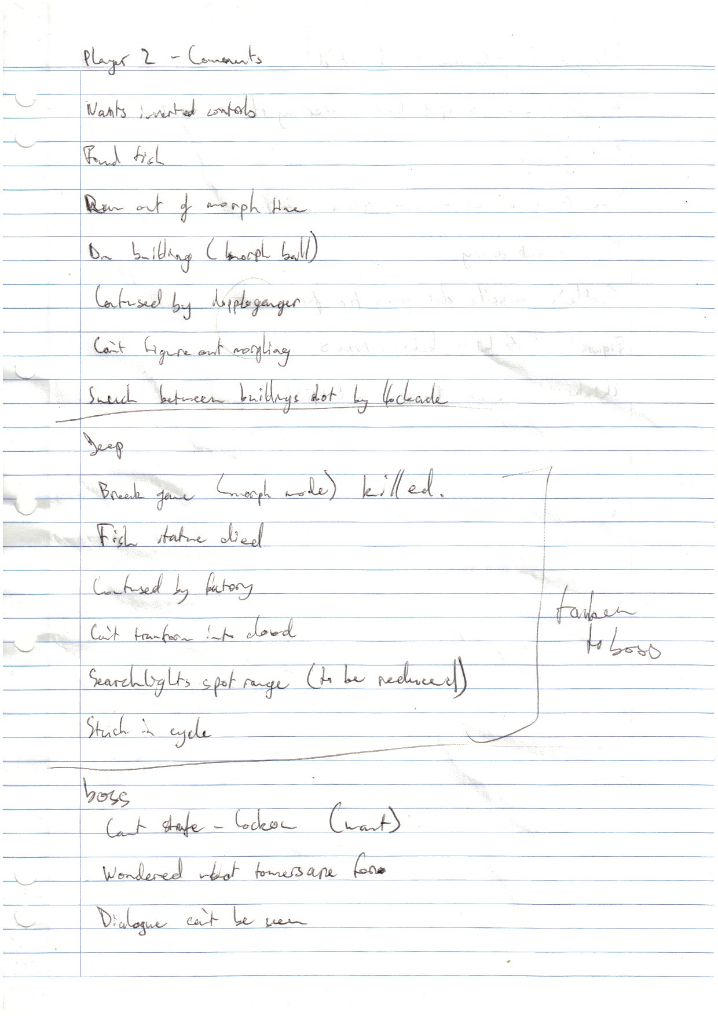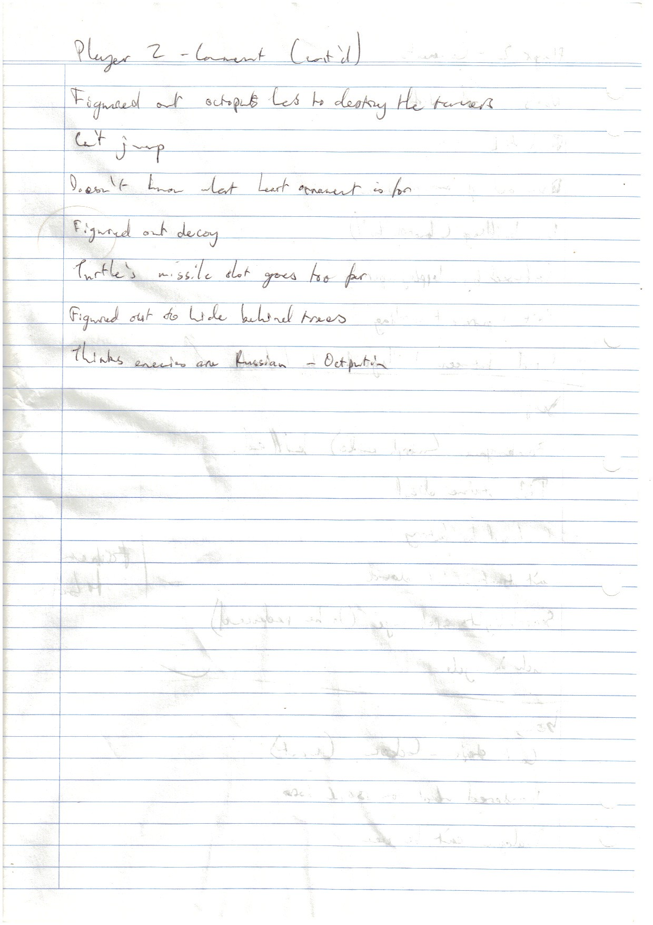

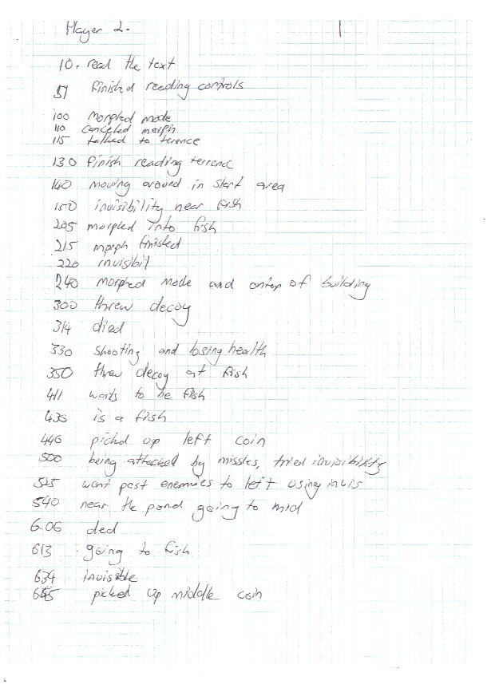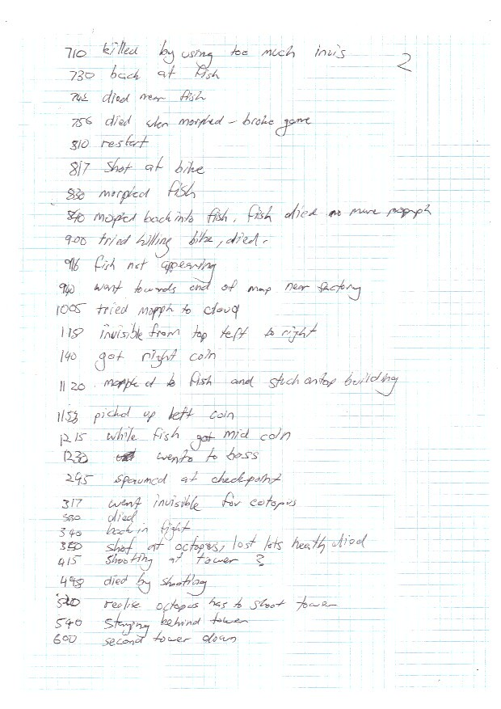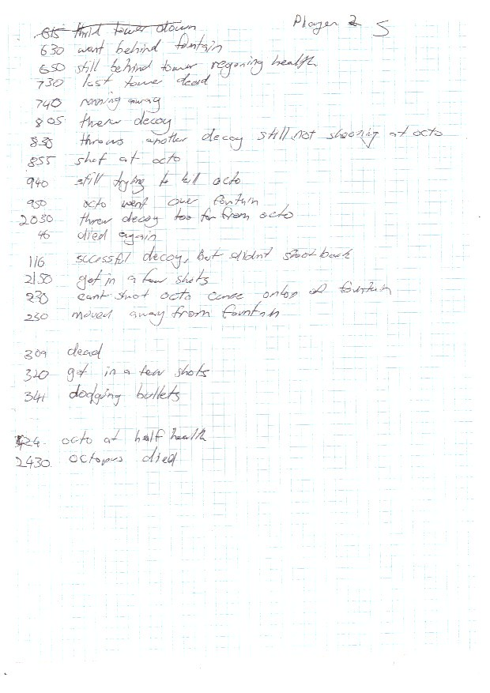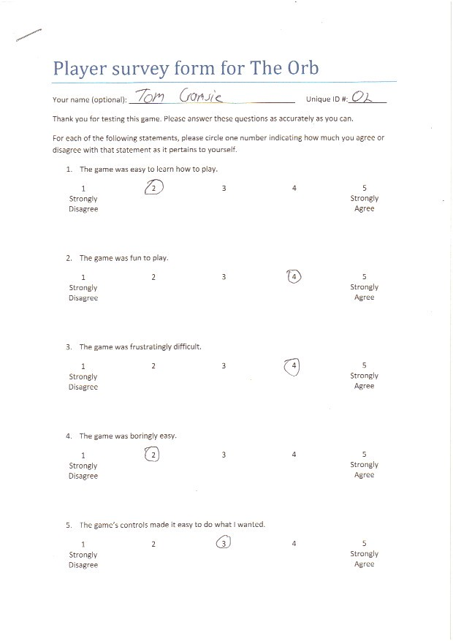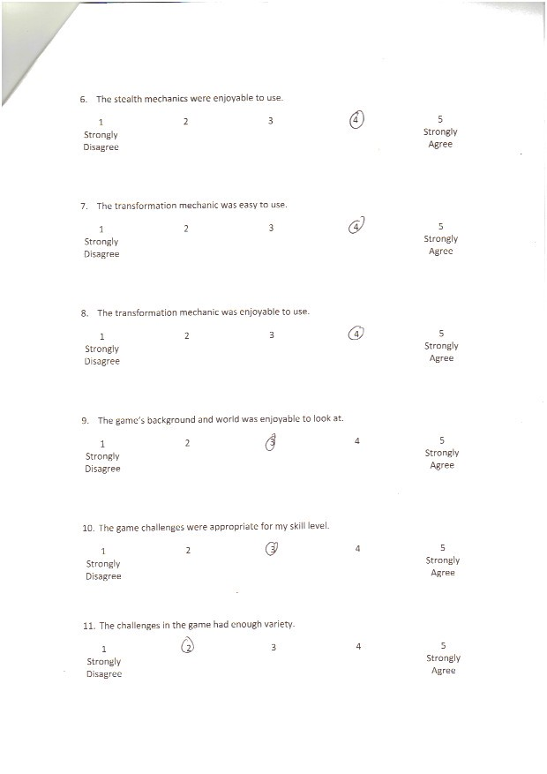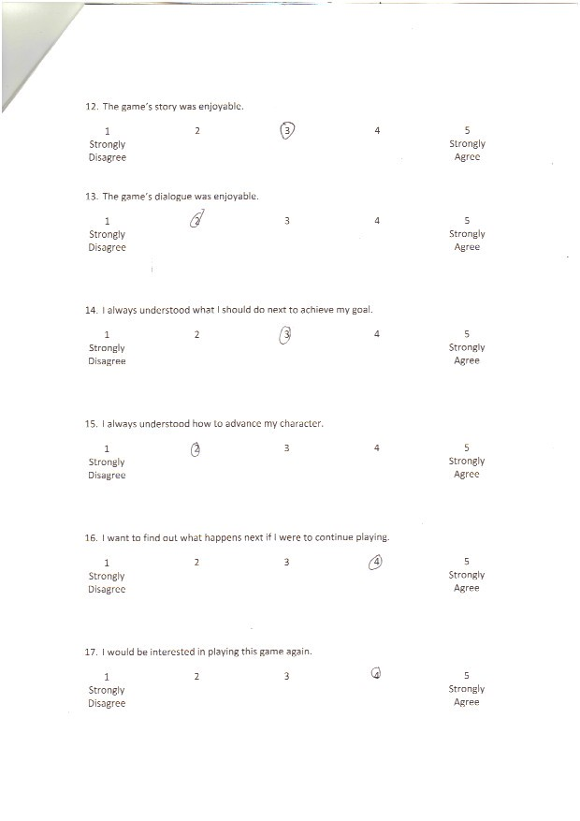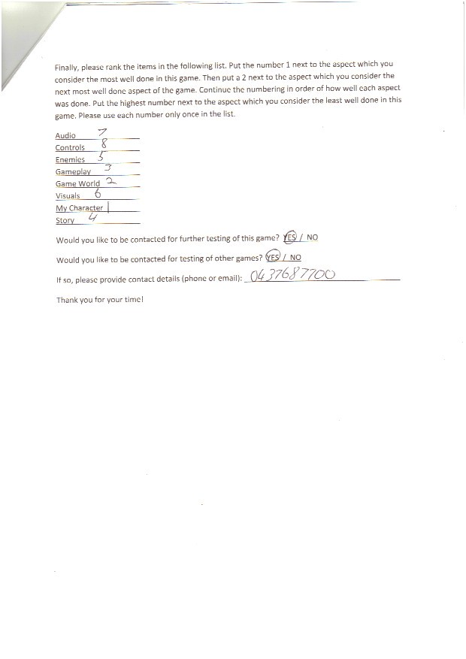

### Tester 3

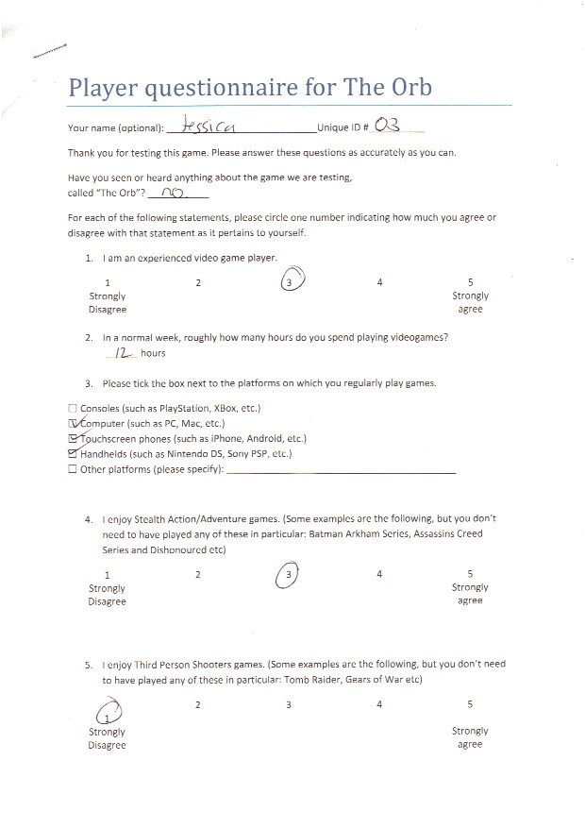

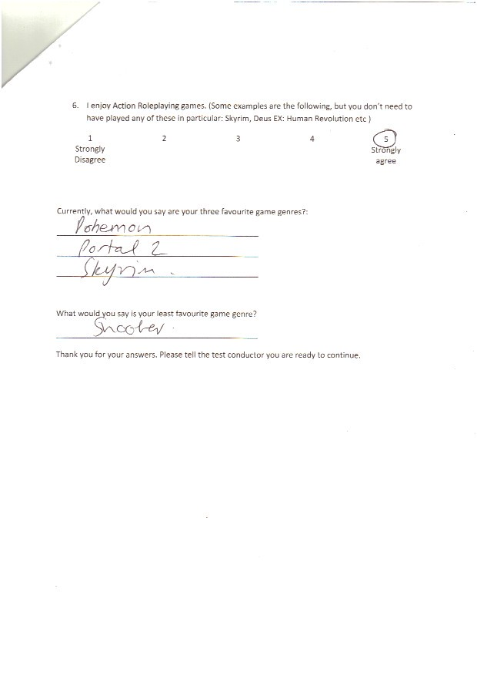

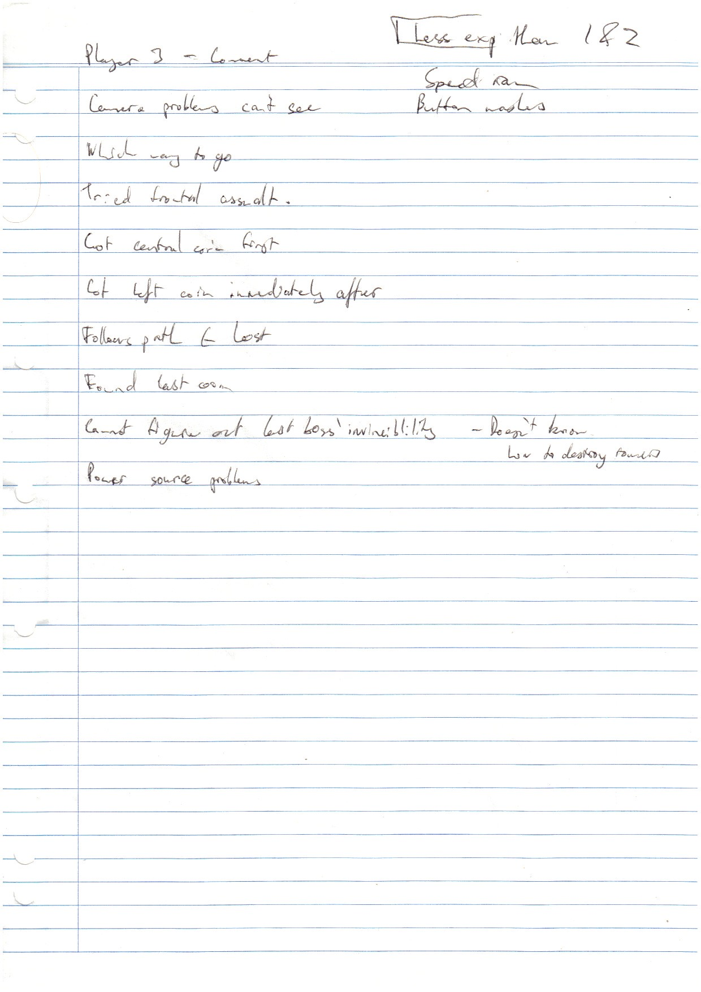

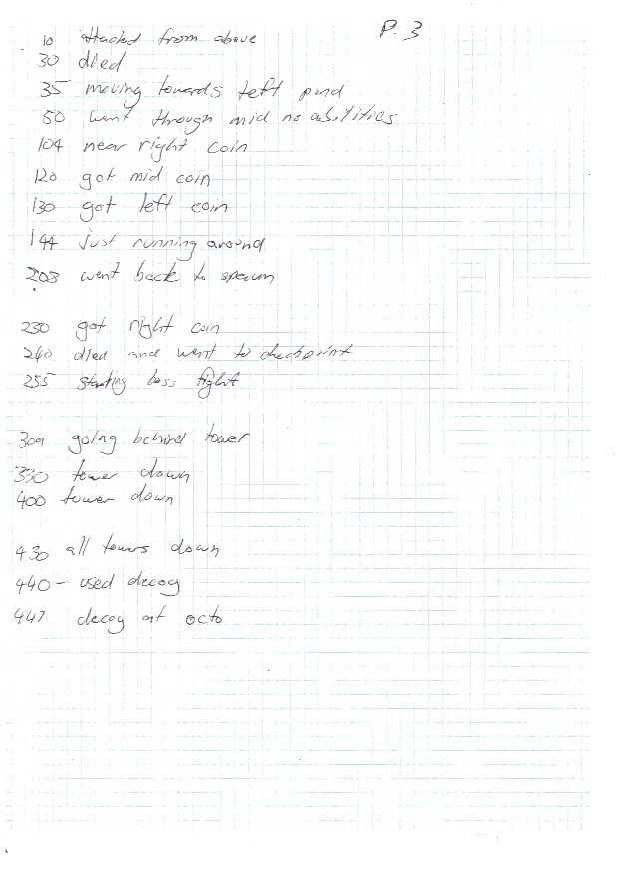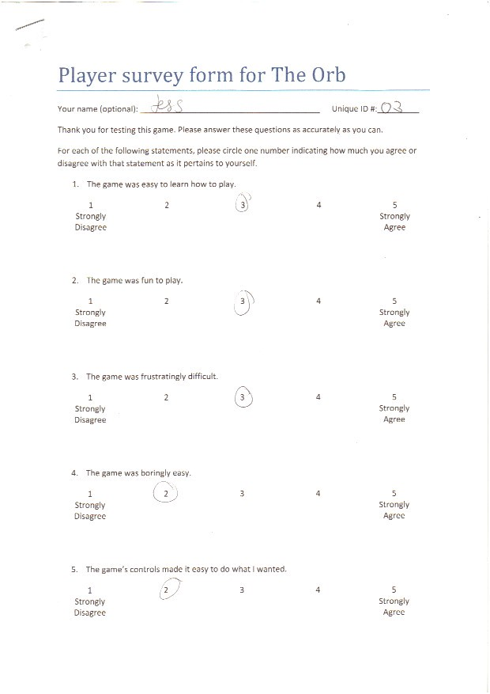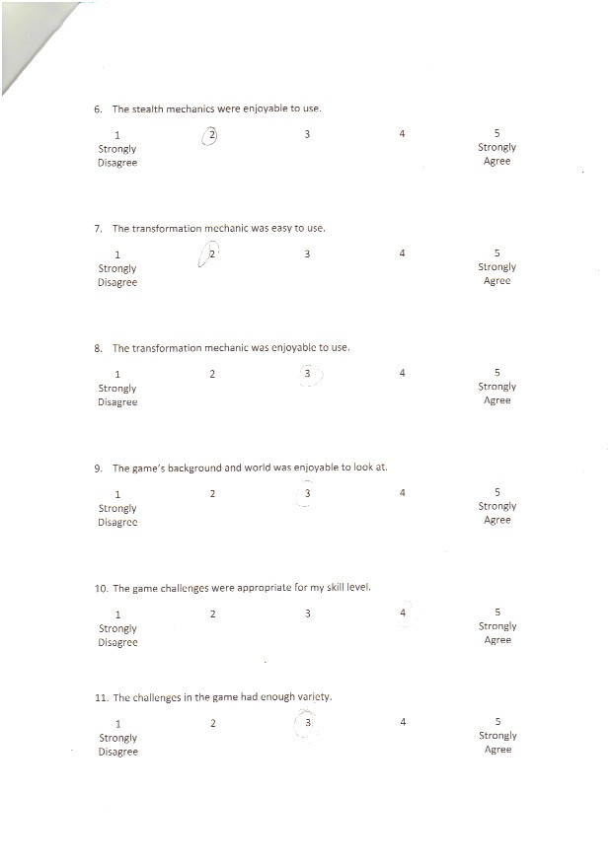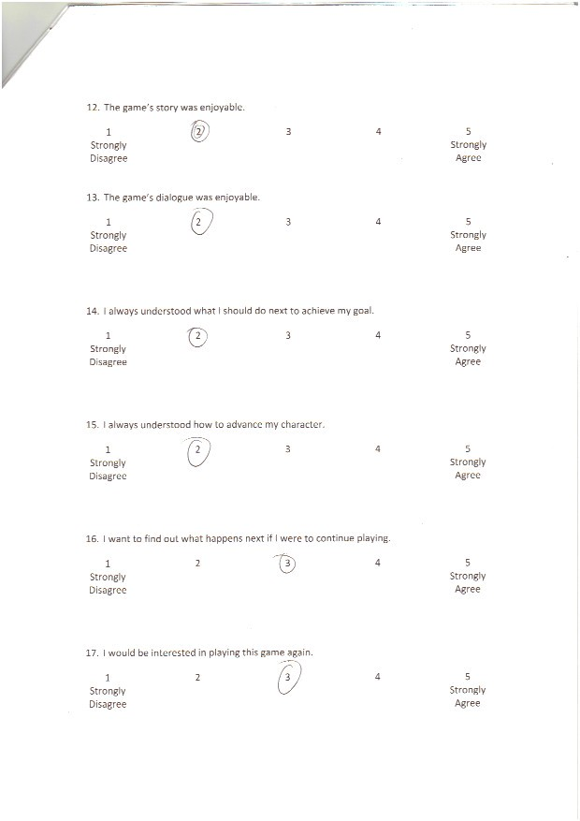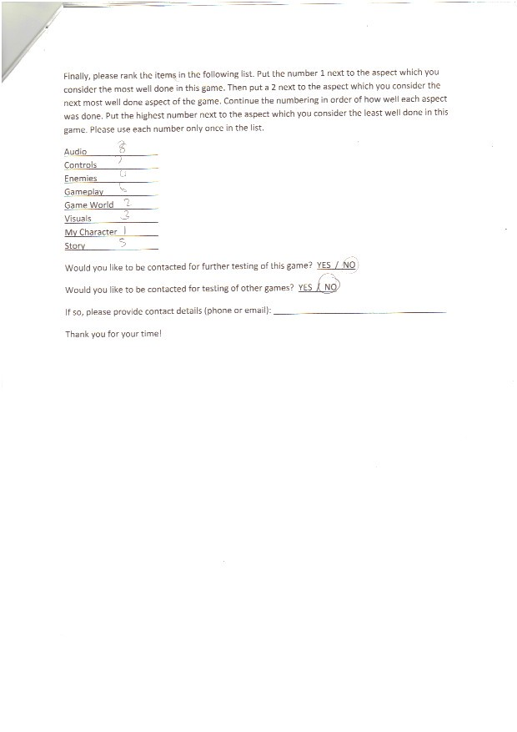

### Tester 4

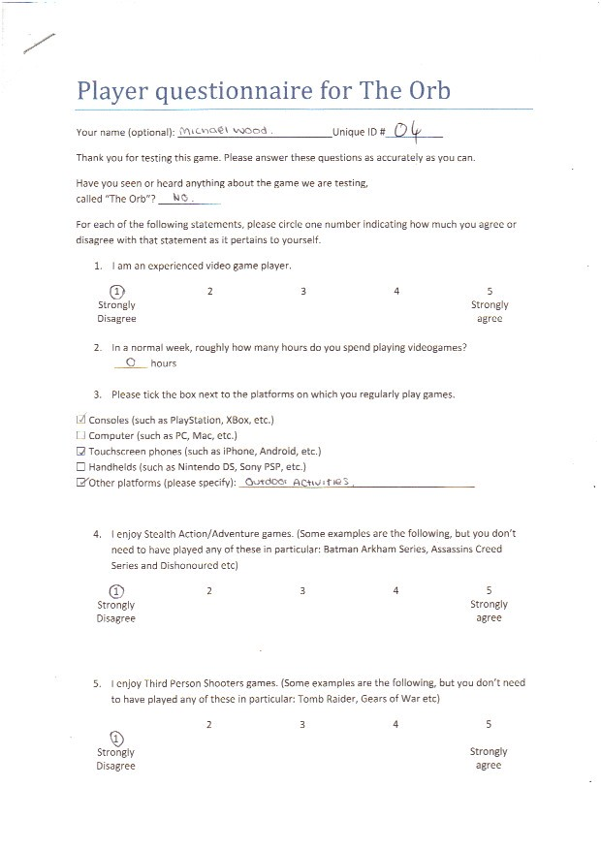

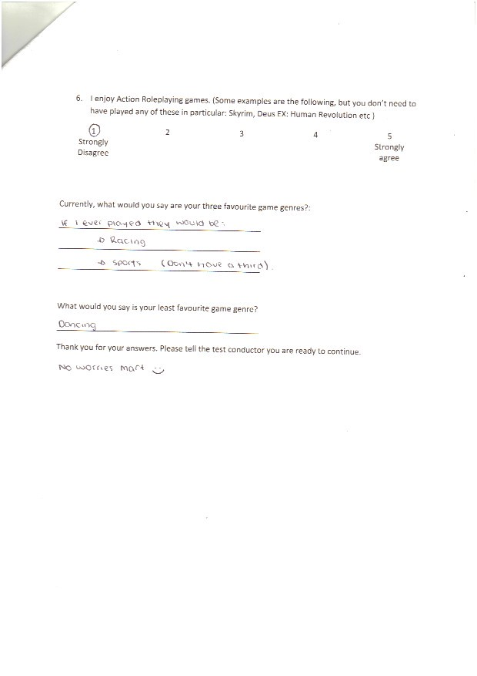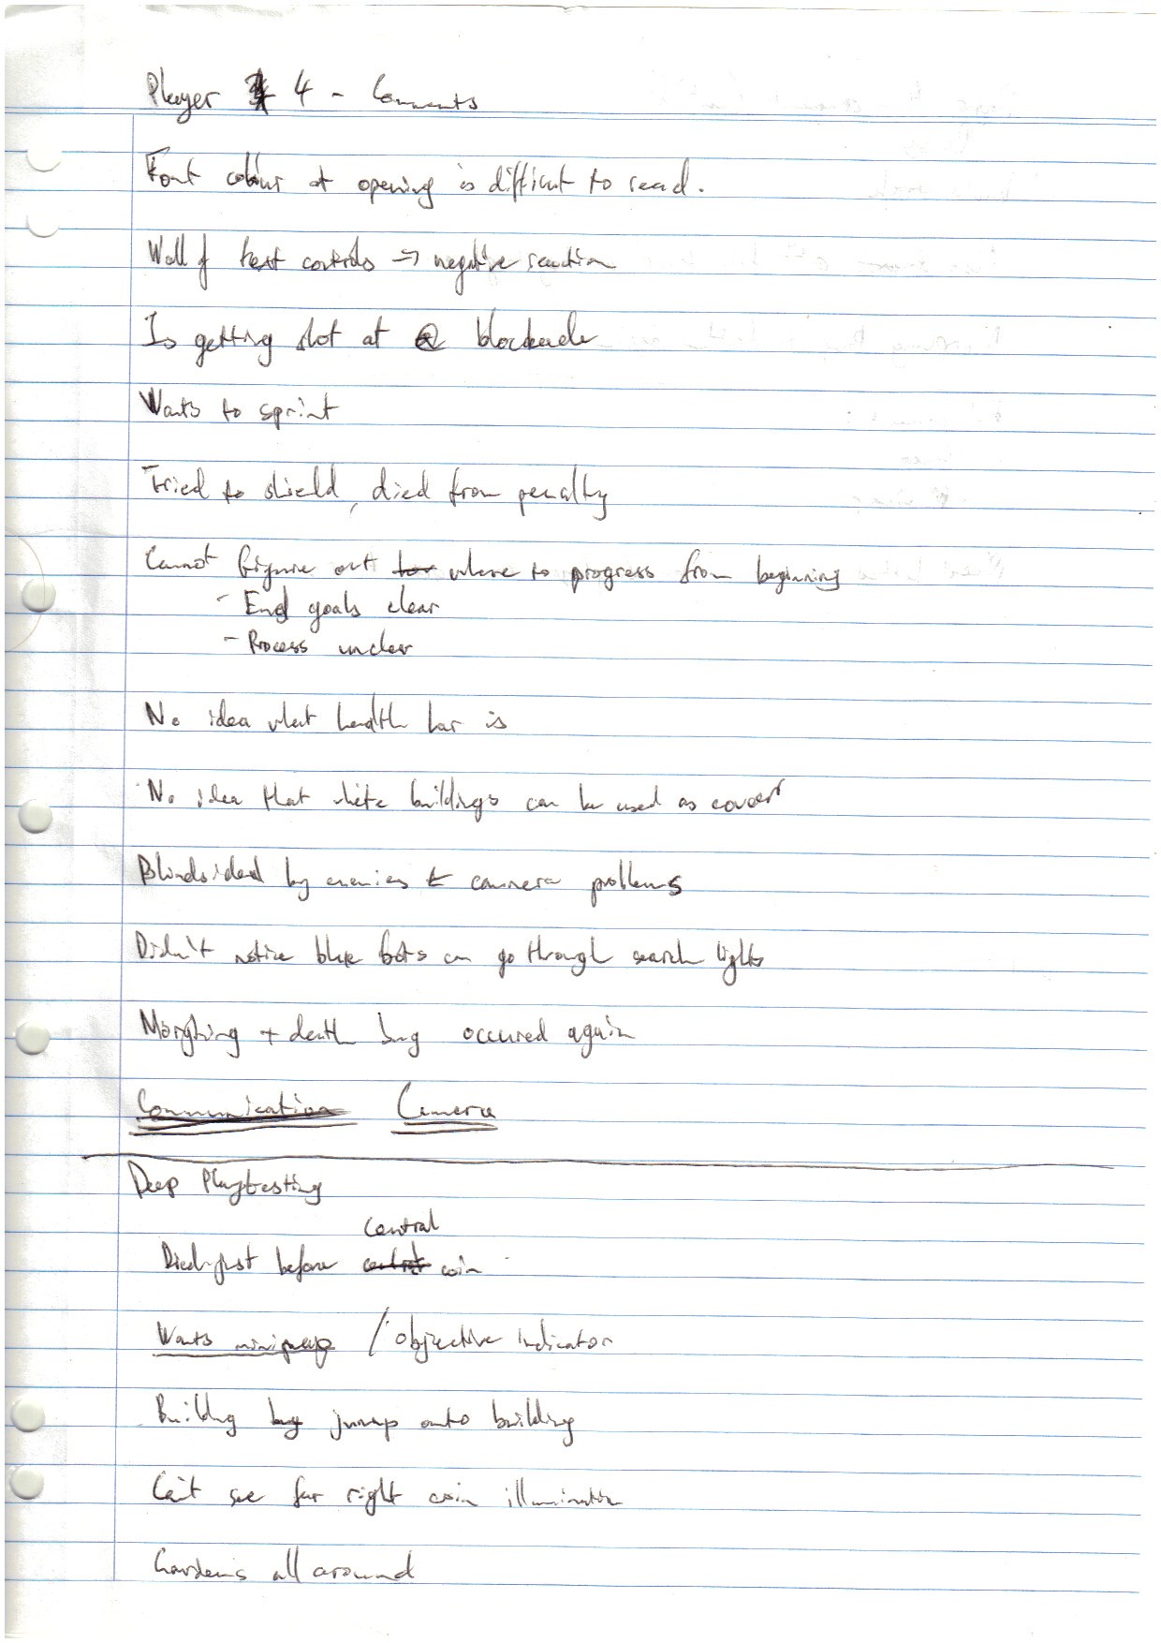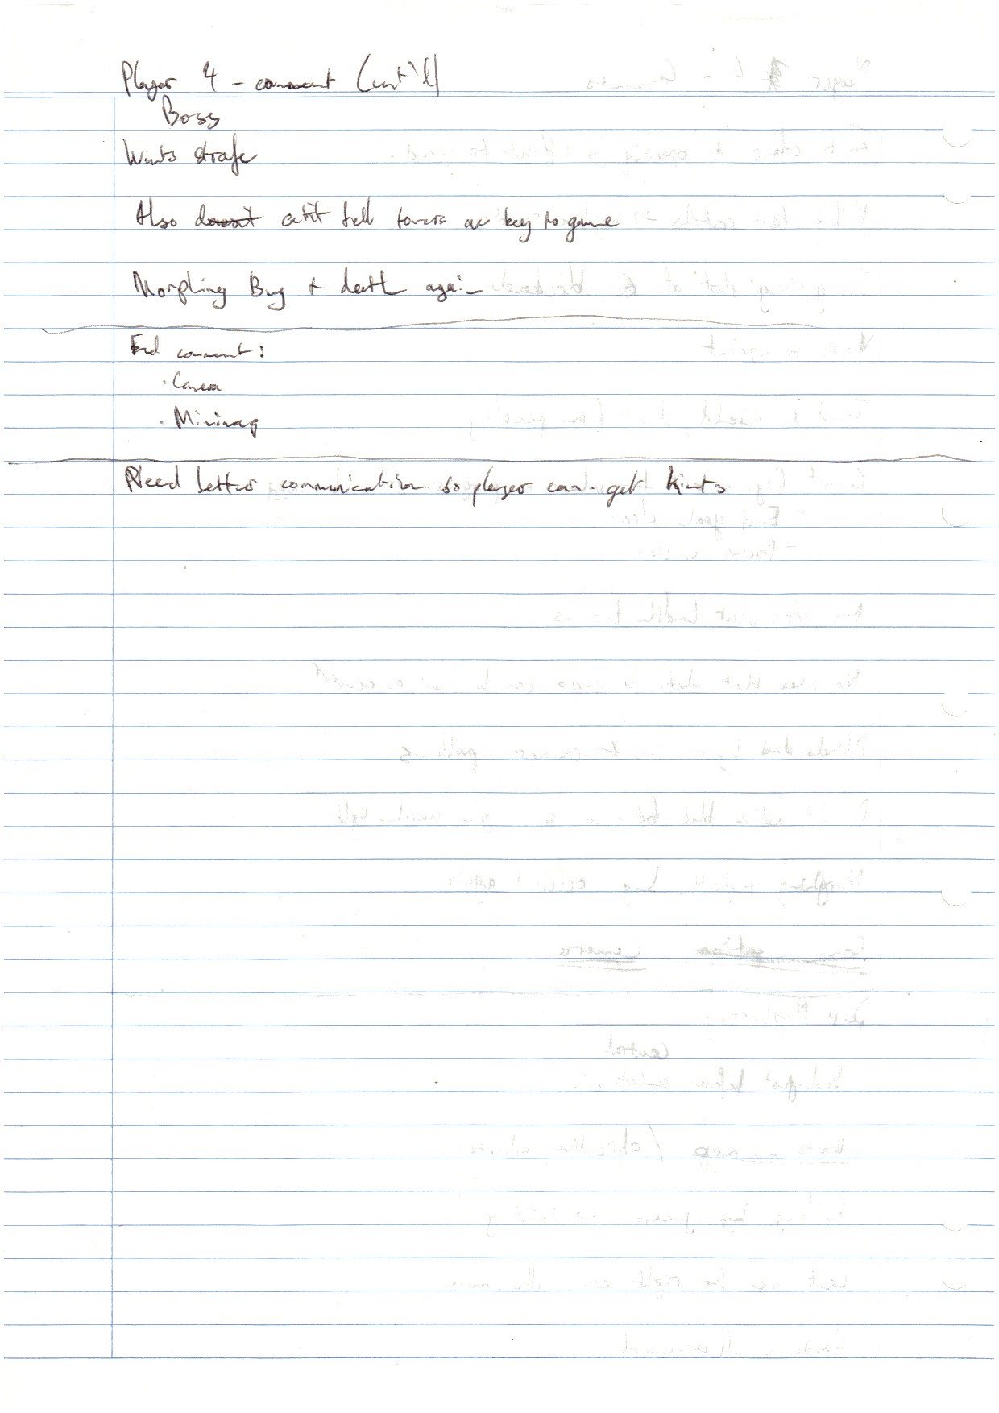

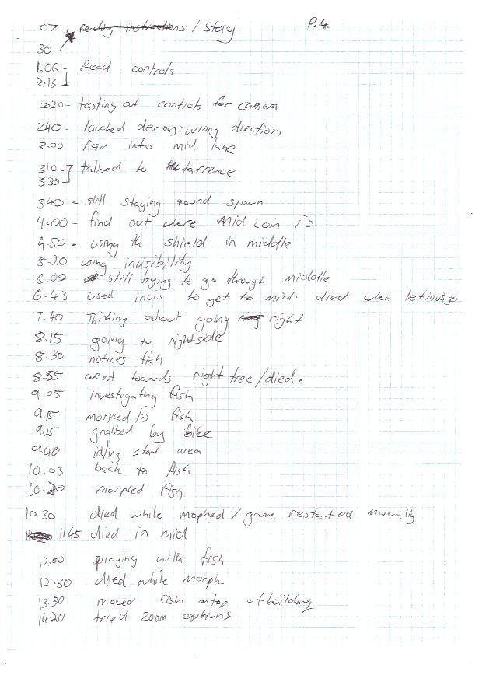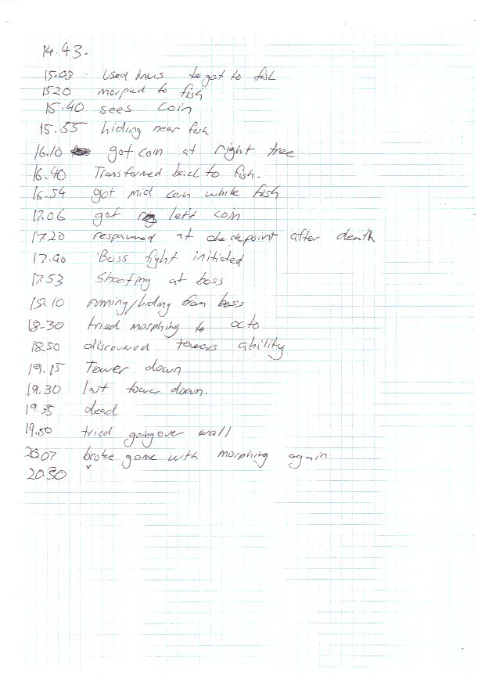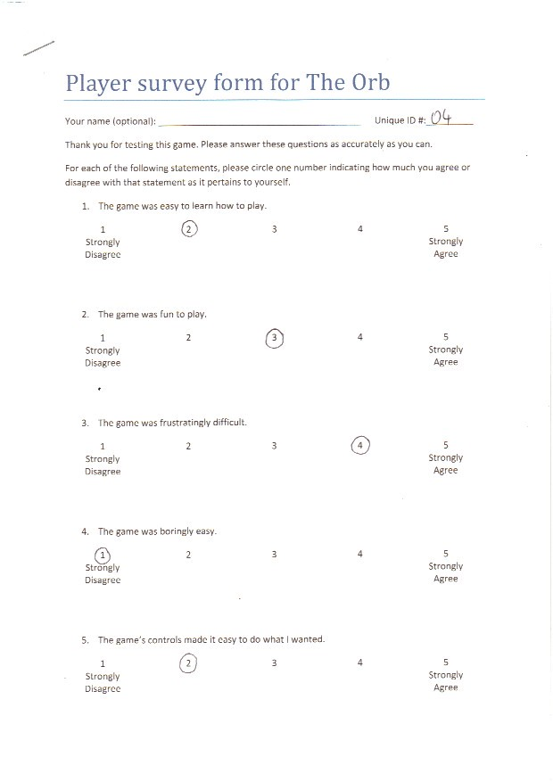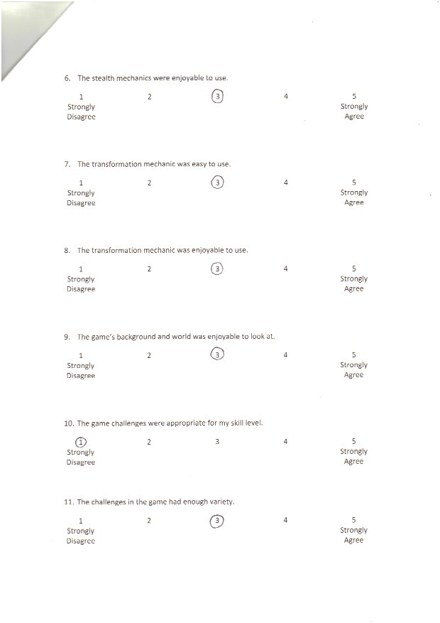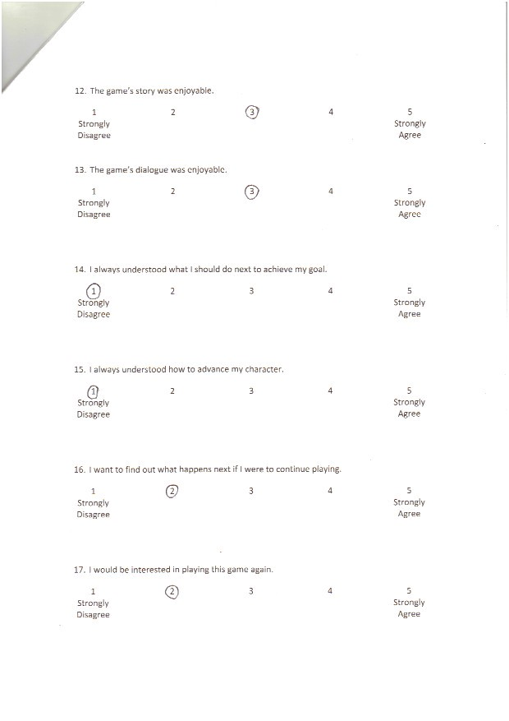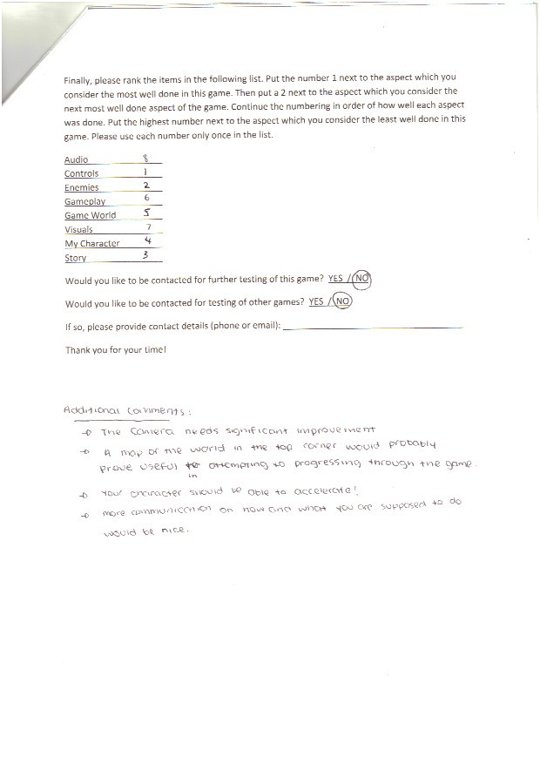

### Tester 5

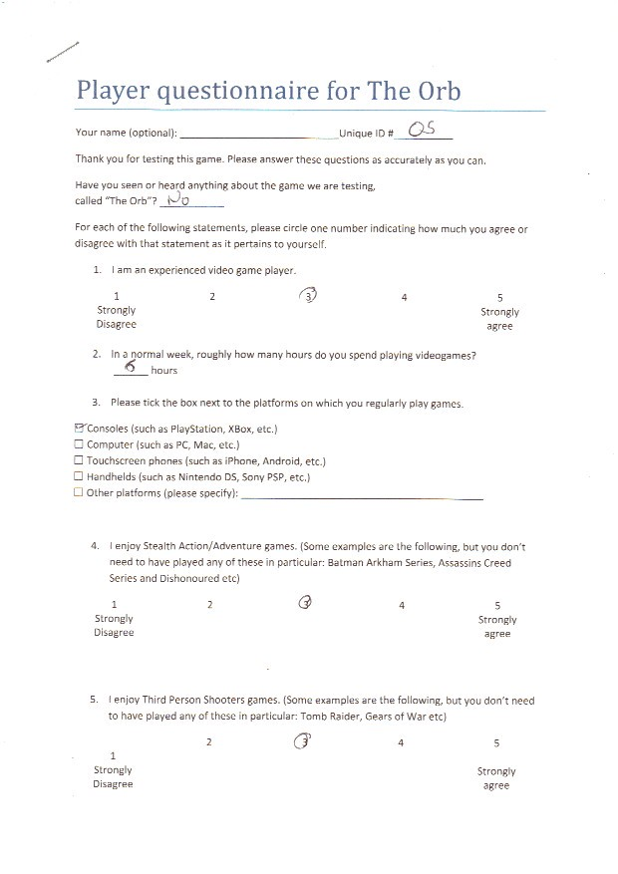

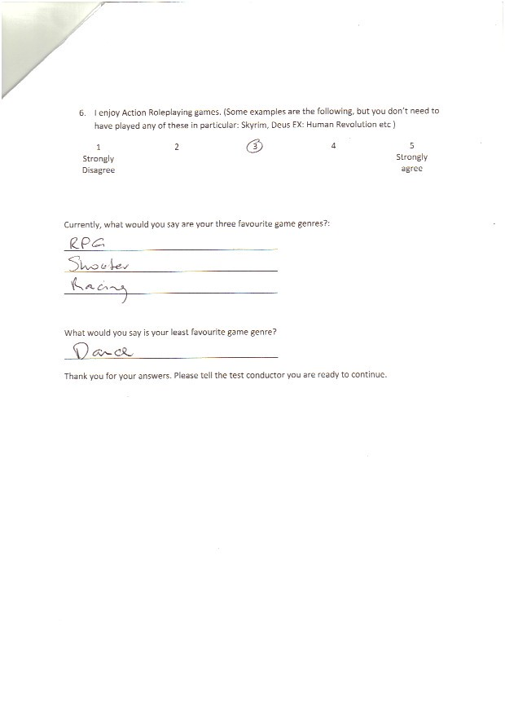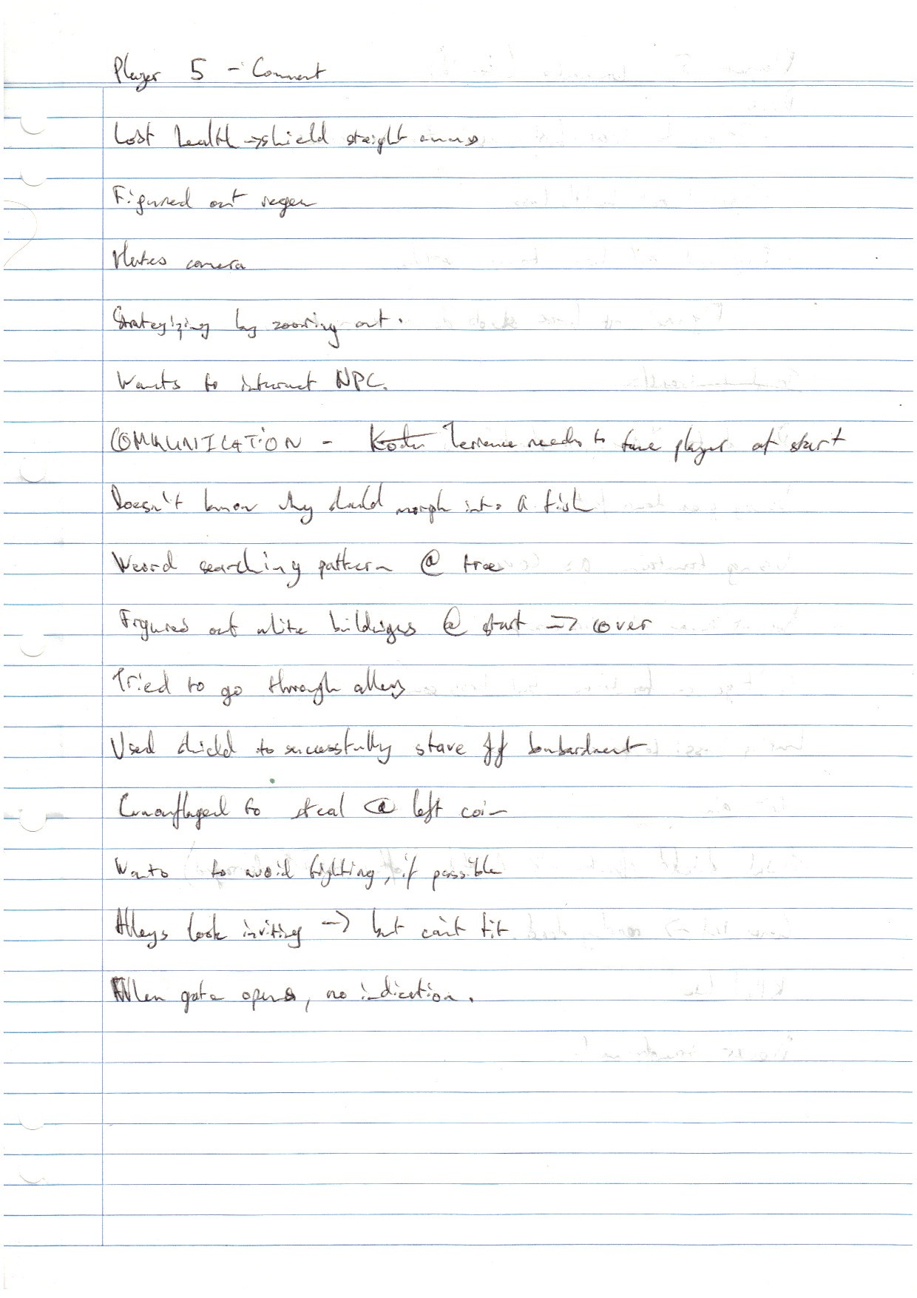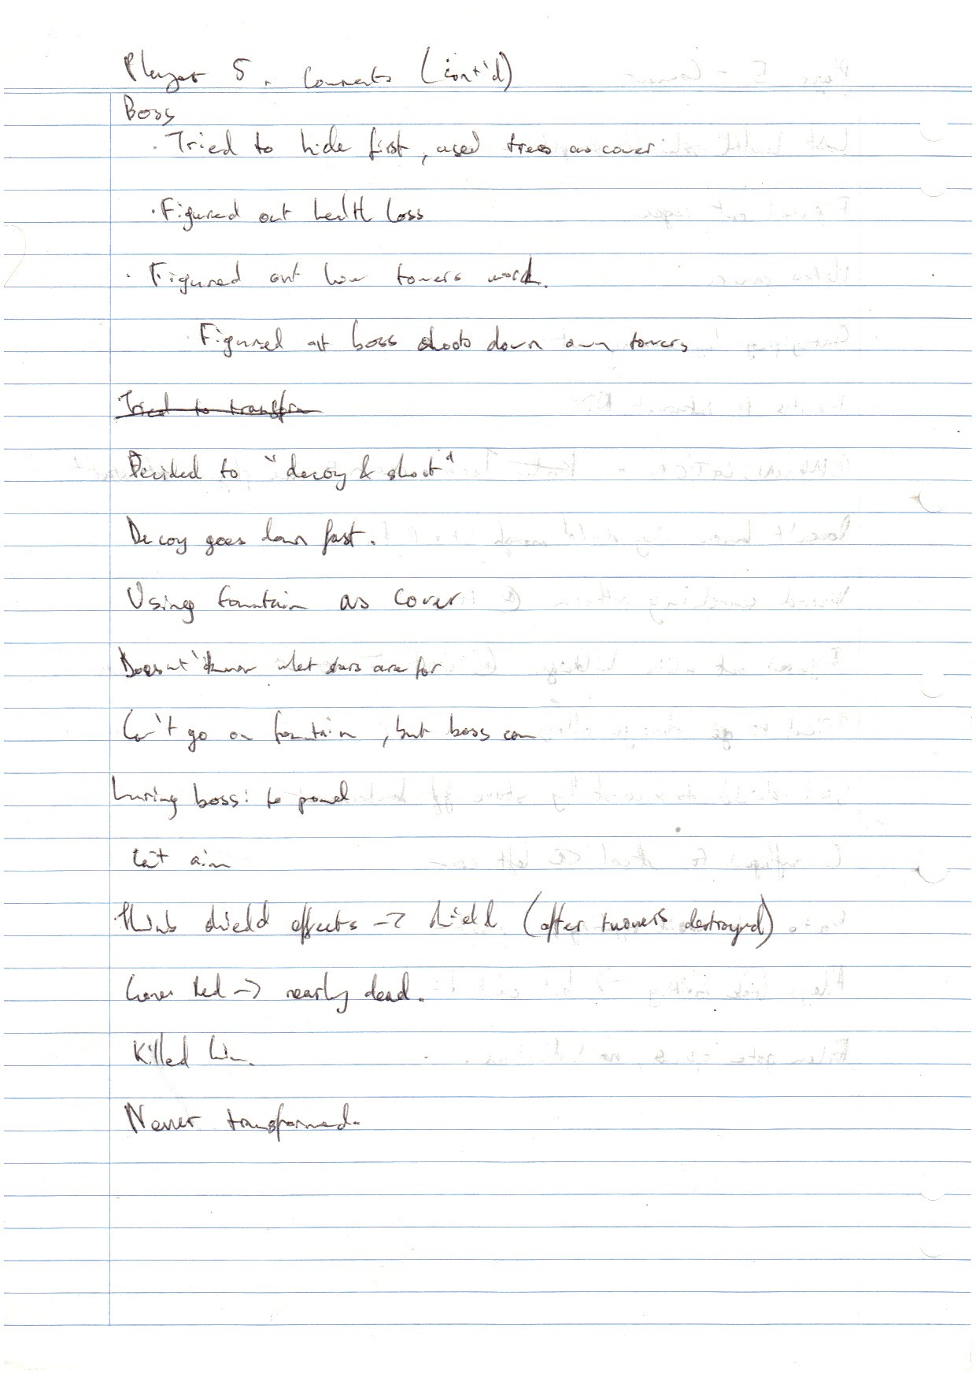

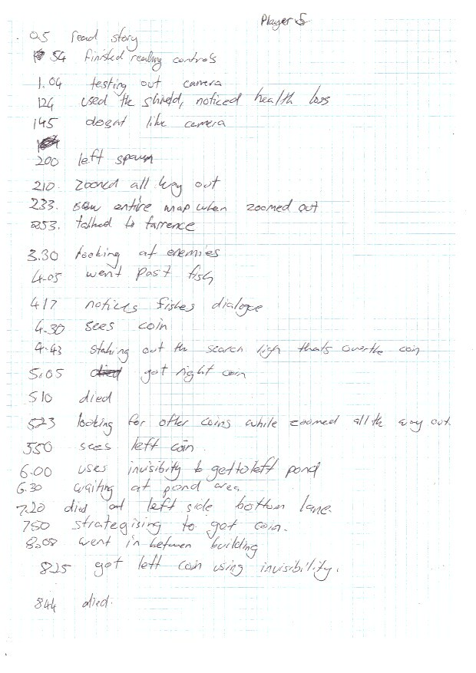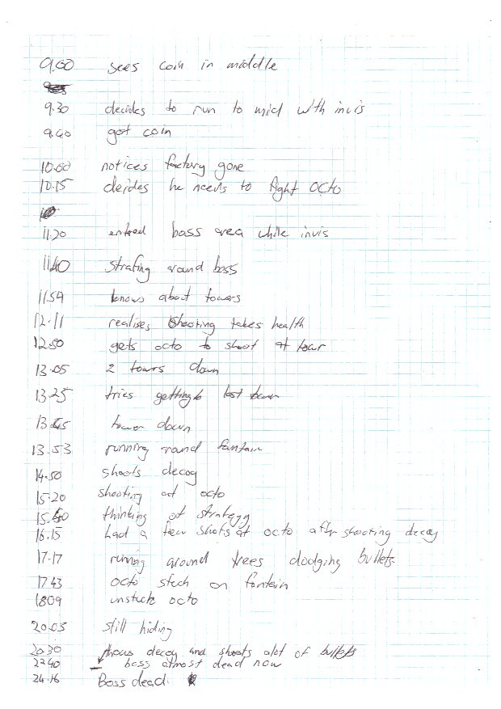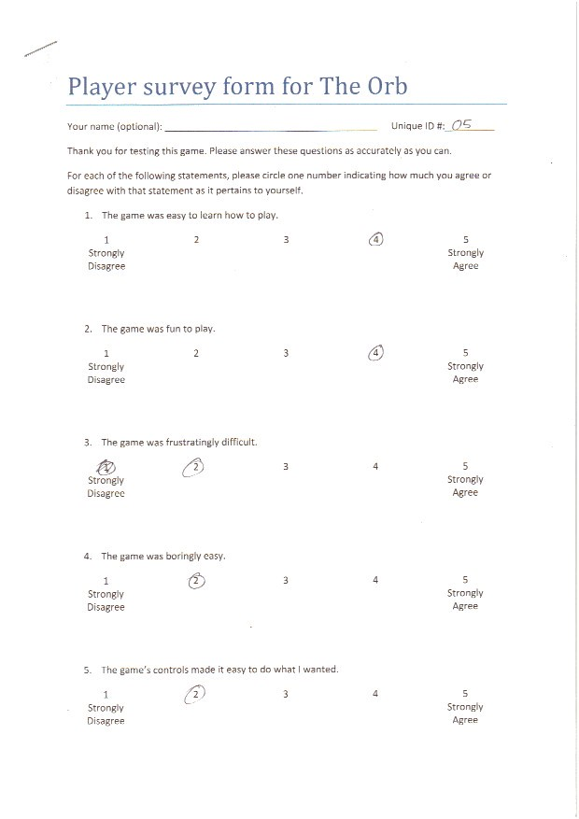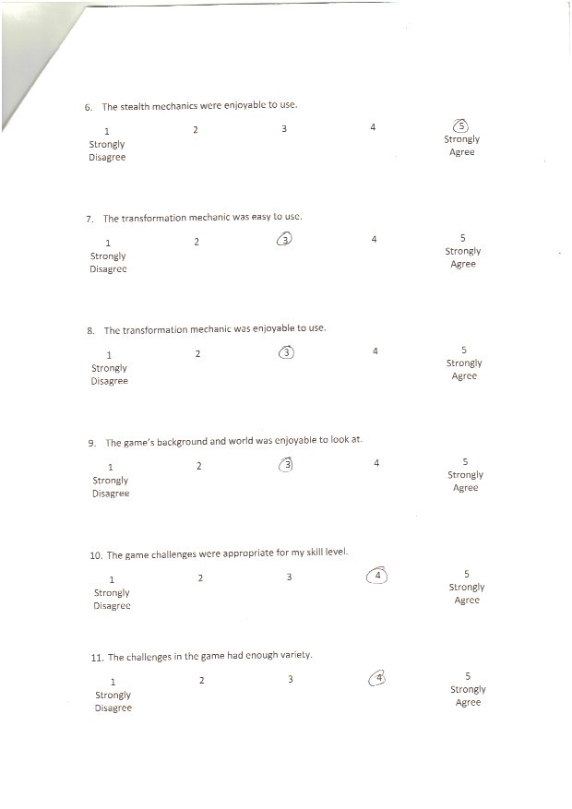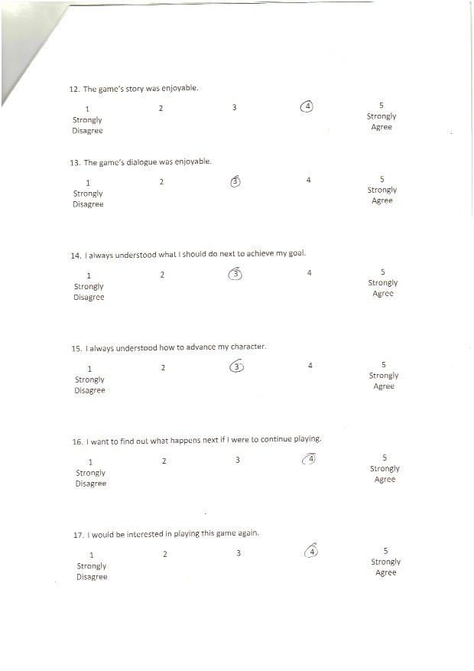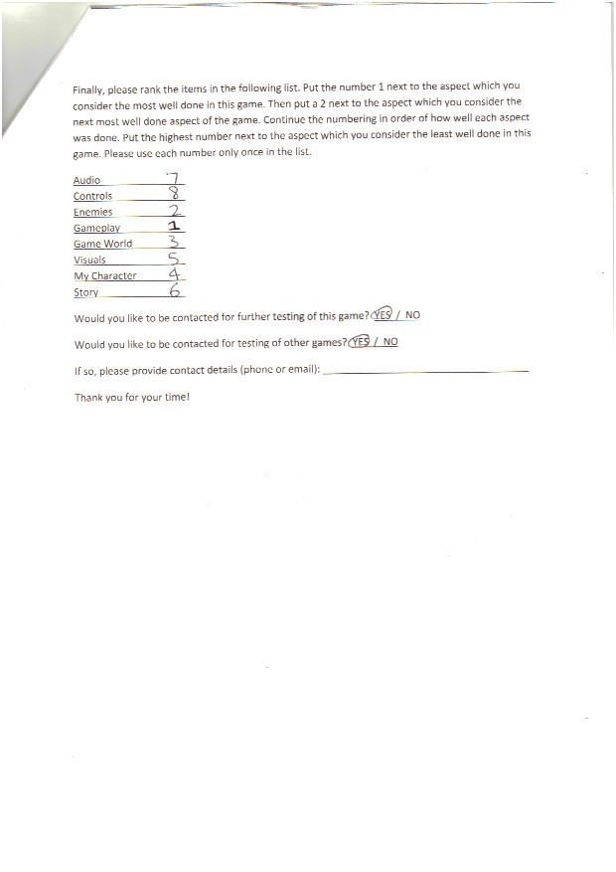

### Test Observer Checklist Tally



### Additional Playtesting Comments and Notes

**Playtesting comments #01**

* The controls are all text based, would rather visual interface
* Wasn’t much instruction on what to do
* Lack of explanation on abilities
* Didn’t know transformation lasted for 20 seconds
* Camera zooming didn’t work and was broken
  + Inverted
* Coins not pounced enough
* Combat Mechanics need work
* Optimization

**Playtesting comments #02**

* Lock on strafe needed
* Inverted camera bad
* Bit more camera freedom
* Localized heads up display – for health mainly
  + Lock on enemies

**Playtesting comments #03**

* Controls
* Biggest problem is camera

**Playtesting comments #04**

* Mini map
* Objective indicator
* Additional Comments on Survey
  + The camera needs significant improvement
  + A map of the world in the top corner would probably prove useful in attempt to progressing through the game
  + Your character should be able to accelerate!
  + More communication on how and what you are supposed to would be nice.

**Playtesting comments #05**

* Octopus communicating towers as week point
  + Simple message would be good
* When camera moves player’s character should move aswell in the same direction

**Additional Notes**

* Transformation not clear enough
  + Colour code system for Enemies, NPC’s and allies
* 2 biggest problems identified (summary of findings and detailed findings
  + Camera Control
  + Communication

## Appendix 2 – Team member Contributions

The construction of the prototype and report was a team effort, with everybody advising and providing feedback on each section written and the prototype itself.

**Danyon Fitzsimon**

* Original Concept
* Level Design
* Character Design
* Script Writing/Playtest Conducting
* Survey and Questionnaire Table
* Vision
* Discussion of Findings.

**Peter Tran**

* A.I.
* Note-taker
* Programing
* Detailed Findings Table

**Muhammed Dogan**

* Gameplay Video
* Prototype Descriptions
* Environment design
* Note -taker.